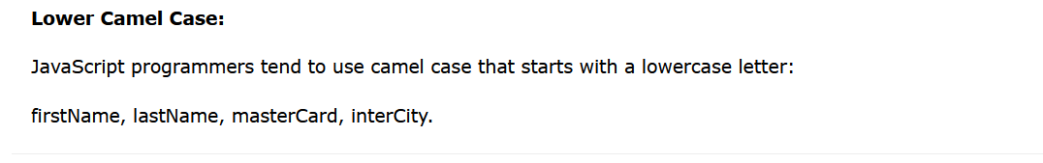

let getName = prompt( “ Enter your name ” );